**The Most-Used Linux Commands**

Before jumping into the most-used Linux commands, make sure to fire up a **terminal**. In most Linux distributions, you would use Ctrl + Alt + T to do so. If this isn’t working, search in your application panel for “terminal.”

[](https://kinsta.com/wp-content/uploads/2021/08/Linux-terminal-emulator.png)The Linux terminal emulator.

Now let’s dive into the 40 most-used Linux commands. Many of these have multiple options you can string to them, so make sure to [check out the commands’ manual](https://linux.die.net/man/1/cp).

**1. ls Command**

ls is probably the first command every Linux user typed in their terminal. It allows you to list the contents of the directory you want (the current directory by default), including files and other nested directories.

ls

It has many options, so it might be good to get some help by using the --help flag. This flag returns all the flags you can use with ls.

For example, to colorize the output of the ls command, you can use the following:

ls --color=auto

[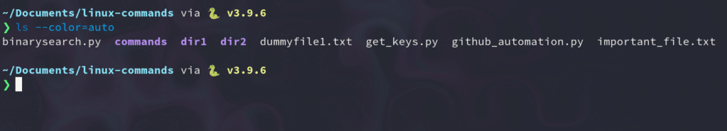](https://kinsta.com/wp-content/uploads/2021/08/ls-command-colorized.png)The colorized ls command.

Now the ls command output is colorized, and you can appreciate the difference between a directory and a file.

But typing ls with the color flag would be inefficient; that’s why we use the alias command.

**2. alias Command**

The alias command lets you define temporary aliases in your shell session. When creating an alias, you instruct your shell to replace a word with a series of commands.

For example, to set ls to have color without typing the --color flag every time, you would use:

alias ls="ls --color=auto"

As you can see, the alias command takes one key-value pair parameter: alias NAME="VALUE". Note that the value must be inside quotes.

If you want to list all the aliases you have in your shell session, you can run the alias command without argument.

alias

[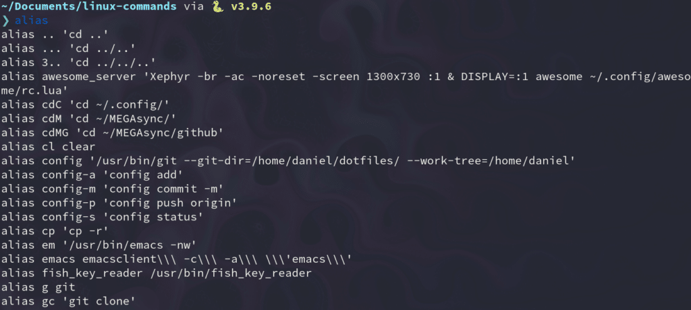](https://kinsta.com/wp-content/uploads/2021/08/alias-command.png)The alias command.

**3. unalias Command**

As the name suggests, the unalias command aims to remove an alias from the already defined aliases. To remove the previous ls alias, you can use:

unalias ls

**4. pwd Command**

The pwd command stands for “print working directory,” and it outputs the absolute path of the directory you’re in. For example, if your username is “john” and you’re in your Documents directory, its absolute path would be: /home/john/Documents.

To use it, simply type pwd in the terminal:

pwd

# My result: /home/kinsta/Documents/linux-commands

**5. cd Command**

The cd command is highly popular, along with ls. It refers to “**c**hange **d**irectory” and, as its name suggests, switches you to the directory you’re trying to access.

For instance, if you’re inside your Documents directory and you’re trying to access one of its subfolders called **Videos**, you can enter it by typing:

cd Videos

You can also supply the absolute path of the folder:

cd /home/kinsta/Documents/Videos

There are some tricks with the cd command that can save you a lot of time when playing around with it:

**1. Go to the home folder**

cd

**2. Move a level up**

cd ..

**3. Return to the previous directory**

cd -

**6. cp Command**

It’s so easy to copy files and folders directly in the Linux terminal that sometimes it can replace conventional file managers.

To use the cp command, just type it along with the source and destination files:

cp file_to_copy.txt new_file.txt

You can also copy entire directories by using the recursive flag:

cp -r dir_to_copy/ new_copy_dir/

Remember that in Linux, folders end with a forward slash (/).

**7. rm Command**

Now that you know how to copy files, it’ll be helpful to know how to remove them.

You can use the rm command to remove files and directories. Be careful while using it, though, because it’s very difficult (yet not impossible) to recover files deleted this way.

To delete a regular file, you’d type:

rm file_to_copy.txt

If you want to delete an empty directory, you can use the recursive (-r) flag:

rm -r dir_to_remove/

On the other hand, to remove a directory with content inside of it, you need to use the force (-f) and recursive flags:

rm -rf dir_with_content_to_remove/

**Info**

Be careful with this — you can erase a whole day of work by misusing these two flags!

**8. mv Command**

You use the mv command to move (or rename) files and directories through your file system.

To use this command, you’d type its name with the source and destination files:

mv source_file destination_folder/

mv command_list.txt commands/

To utilize absolute paths, you’d use:

mv /home/kinsta/BestMoviesOfAllTime ./

…where ./ is the directory you’re currently in.

You also can use mv to rename files while keeping them in the same directory:

mv old_file.txt new_named_file.txt

**9. mkdir Command**

To create folders in the shell, you use the mkdir command. Just specify the new folder’s name, ensure it doesn’t exist, and you’re ready to go.

For example, to make a directory to keep [all of your images](https://kinsta.com/blog/free-images-for-wordpress/), just type:

mkdir images/

To create subdirectories with a simple command, use the parent (-p) flag:

mkdir -p movies/2004/

**10. man Command**

Another essential Linux command is man. It displays the manual page of any other command (as long as it has one).

To see the manual page of the mkdir command, type:

man mkdir

You could even refer to the man manual page:

man man

[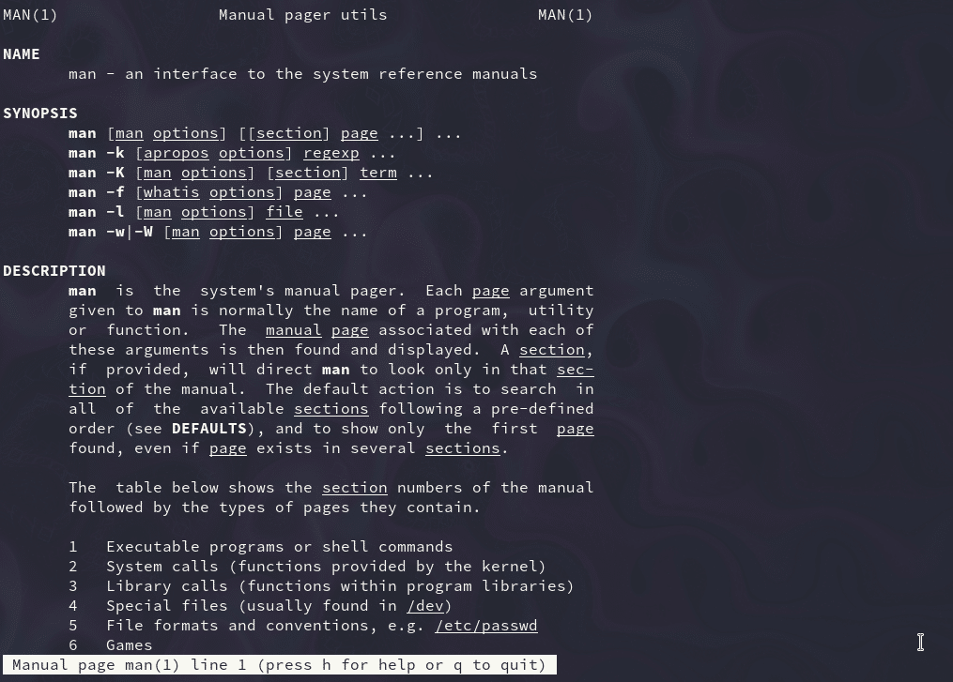](https://kinsta.com/wp-content/uploads/2021/08/Man-command.png)The manual page of “man.”

**11. touch Command**

The touch command allows you to update the access and modification times of the specified files.

For example, I have an old file that was last modified on April 12th:

[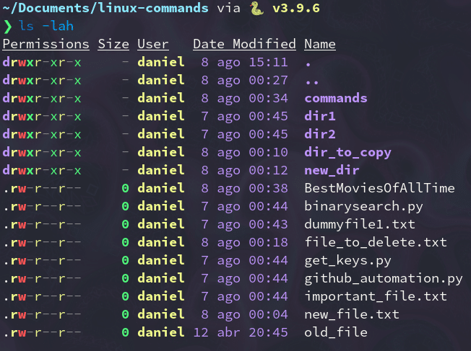](https://kinsta.com/wp-content/uploads/2021/08/old-date.png)Old date.

To change its modification date to the current time, we need to use the -m flag:

touch -m old_file

Now the date matches today’s date (which at the time of writing was August 8th).

[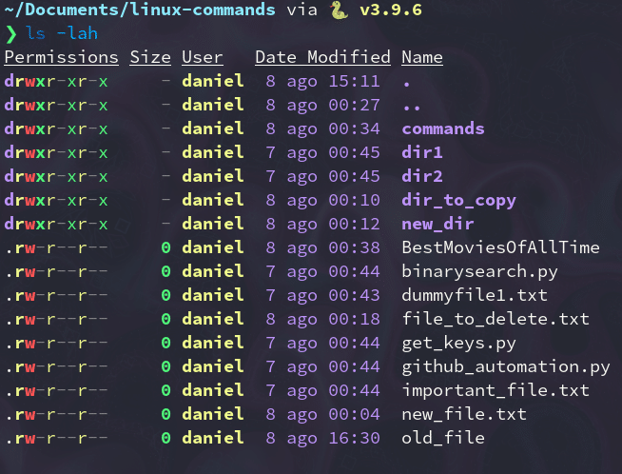](https://kinsta.com/wp-content/uploads/2021/08/new-date.png)New date

Nonetheless, most of the time, you won’t use touch to modify file dates, but rather to create new empty files:

touch new_file_name

**12. chmod Command**

The chmod command lets you change the [mode of a file](https://wiki.archlinux.org/title/File_permissions_and_attributes) (permissions) quickly. It has a lot of options available with it.

The basic permissions a file can have are:

* r (read)
* w (write)
* x (execute)

One of the most common use cases for chmod is to make a file executable by the user. To do this, type chmod and the flag +x, followed by the file you want to modify permissions on:

chmod +x script

You use this to make scripts executable, allowing you to run them directly by using the ./ notation.

**13. ./ Command**

Maybe the ./ notation isn’t a command itself, but it’s worth mentioning in this list. It lets your shell run an executable file with any interpreter installed in your system directly from the terminal. No more double-clicking a file in a graphical file manager!

For instance, with this command, you can run a [Python script](https://kinsta.com/blog/python-object-oriented-programming/) or a program only available in .run format, like [XAMPP](https://kinsta.com/blog/install-wordpress-locally/#how-to-install-wordpress-locally-using-xampp). When running an executable, make sure it has executable (x) permissions, which you can modify with the chmod command.

Here’s a simple Python script and how we would run it with the ./ notation:

#! /usr/bin/python3

# filename: script

for i in range(20):

print(f"This is a cool script {i}")

Here’s how we’d convert the script into an executable and run it:

chmod +x script

./script

**14. exit Command**

The exit command does exactly what its name suggests: With it, you can end a shell session and, in most cases, automatically close [the terminal](https://kinsta.com/blog/how-to-use-ssh/) you’re using:

exit

**15. sudo Command**

This command stands for “superuser do,” and it lets you act as a superuser or root user while you’re running a specific command. It’s how Linux protects itself and prevents users from accidentally modifying the machine’s filesystem or installing inappropriate packages.

Sudo is commonly used to install software or to edit files outside the user’s home directory:

sudo apt install gimp

sudo cd /root/

It’ll ask you for the administrator’s password before running the command you typed after it.

**16. shutdown Command**

As you may guess, the shutdown command lets you power off your machine. However, it also can be used to halt and reboot it.

To power off your computer immediately (the default is one minute), type:

shutdown now

You can also schedule to turn off your system in a 24-hour format:

shutdown 20:40

To cancel a previous shutdown call, you can use the -c flag:

shutdown -c

**17. htop Command**

htop is an interactive process viewer that lets you manage your machine’s resources directly from the terminal. In most cases, it isn’t installed d by default, so make sure to read more about it [on its download page](https://htop.dev/downloads.html).

Top of Form

Bottom of Form

Top of Form

Bottom of Form

**Want to know how we increased our traffic over 1000%?**

Join 20,000+ others who get our weekly newsletter with insider WordPress tips!

[Subscribe Now](https://kinsta.com/blog/linux-commands/#newsletter)

htop

[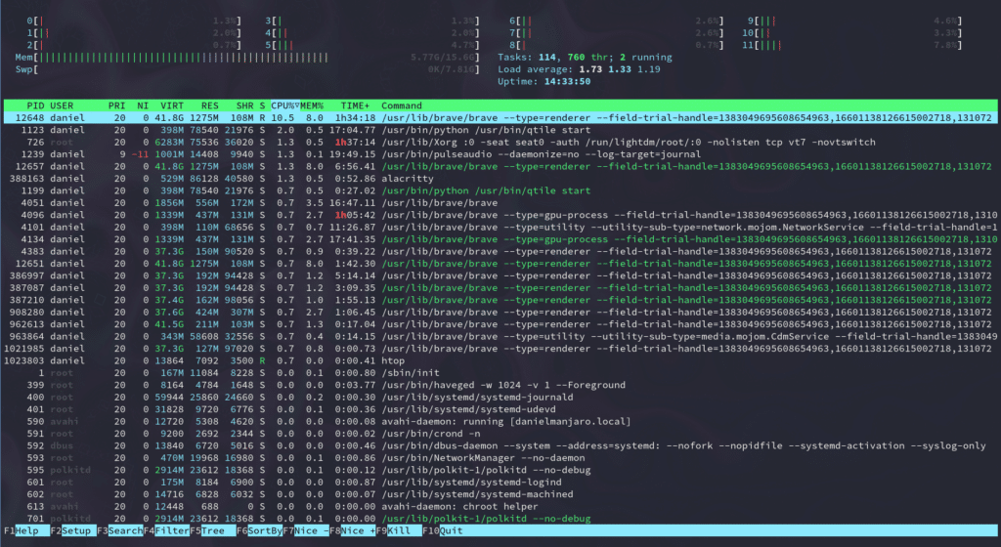](https://kinsta.com/wp-content/uploads/2021/08/htop-interface.png)The “htop” interface.

**18. unzip Command**

The [unzip](https://kinsta.com/knowledgebase/unzip-zip-file/#step-3--unzip-the-zip-file-using-terminal) command allows you to extract the content of a **.zip** file from the terminal. Once again, this package may not be installed by default, so make sure you install it with your package manager.

Here, we’re unpacking a .zip file full of images:

unzip images.zip

**19. apt, yum, pacman commands**

No matter which Linux distribution you’re using, it’s likely that you use package managers to install, update, and remove the software you use every day.

You can access these package managers through the command line, and you’d use one or another depending on the distro your machine is running.

The following examples will install [GIMP](https://www.gimp.org/), a free and open source software usually available in most package managers:

**1. Debian-based (Ubuntu, Linux Mint)**

sudo apt install gimp

**2. Red Hat-based (Fedora, CentOS)**

sudo yum install gimp

**3. Arch-based (Manjaro, Arco Linux)**

sudo pacman -S gimp

**20. echo Command**

The echo command displays defined text in the terminal — it’s that simple:

echo "Cool message"

[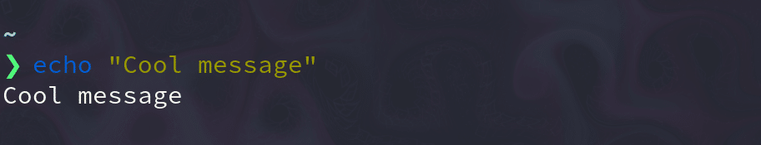](https://kinsta.com/wp-content/uploads/2021/08/echo-command.png)The echo command

Its primary usage is to print environmental variables inside those messages:

echo "Hey $USER"

# Hey kinsta

**21. cat Command**

Cat, short for “concatenate,” lets you create, view, and concatenate files directly from the terminal. It’s mainly used to preview a file without opening a graphical text editor:

cat long_text_file.txt

[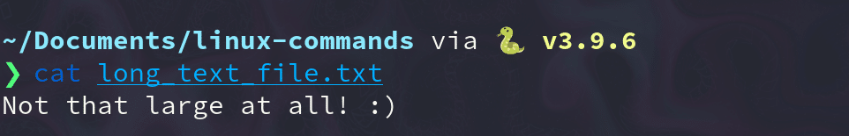](https://kinsta.com/wp-content/uploads/2021/08/cat-command.png)The cat command.

**22. ps Command**

With ps, you can take a look at the processes your current shell session is running. It prints useful information about the programs you’re running, like process ID, TTY (TeleTYpewriter), time, and command name.

ps

[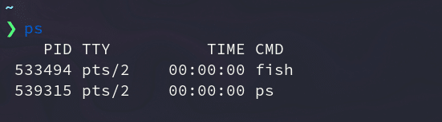](https://kinsta.com/wp-content/uploads/2021/08/ps-command.png)The ps command.

In case you want something more interactive, you can use htop.

**23. kill Command**

It’s annoying when a program is unresponsive, and you can’t close it by any means. Fortunately, the kill command solves this kind of problem.

Simply put, kill sends a TERM or kill signal to a process that terminates it.

You can kill processes by entering either the PID (processes ID) or the program’s binary name:

kill 533494

kill firefox

Be careful with this command — with kill, you run the risk of accidentally deleting the work you’ve been doing.

**24. ping Command**

ping is the most popular networking terminal utility used to test network connectivity. ping has a ton of options, but in most cases, you’ll use it to request a domain or [IP address](https://kinsta.com/tools/what-is-my-ip/):

ping google.com

ping 8.8.8.8

**25. vim Command**

vim is a free and open source terminal text editor that’s in used since the ’90s. It lets you edit plain text files using efficient keybindings.

Some people consider it difficult to use — [exiting Vim](https://stackoverflow.com/questions/11828270/how-do-i-exit-the-vim-editor) is one of the most-viewed StackOverflow questions — but once you get used to it, it becomes your best ally in the command line.

To fire up Vim, just type:

All Kinsta hosting plans include 24/7 support from our veteran WordPress developers and engineers. Chat with the same team that backs our Fortune 500 clients. [Check out our plans](https://kinsta.com/plans/)!

vim

[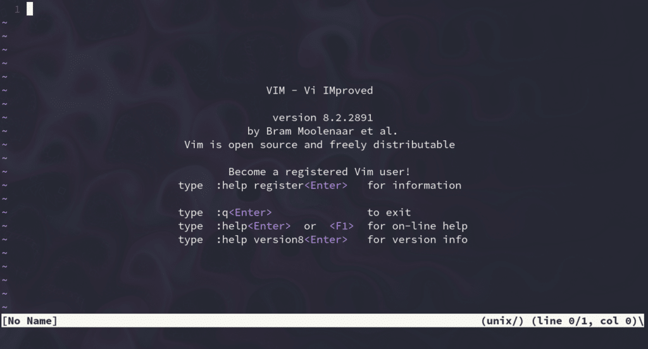](https://kinsta.com/wp-content/uploads/2021/08/vim-text-editor.png)The vim text editor.

**26. history Command**

If you’re struggling to remember a command, history comes in handy. This command displays an enumerated list with the commands you’ve used in the past:

history

[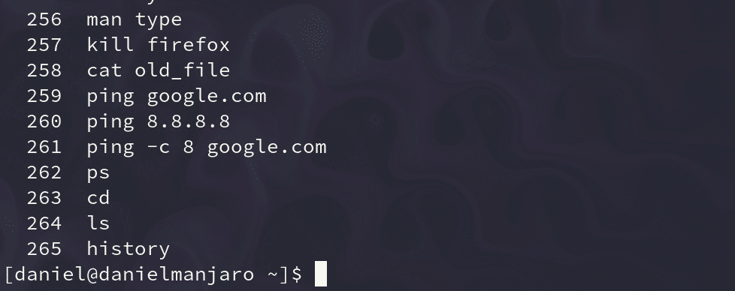](https://kinsta.com/wp-content/uploads/2021/08/history-command.png)The history command.

**27. passwd Command**

passwd allows you to [change the passwords](https://kinsta.com/blog/change-wordpress-password/) of user accounts. First, it prompts you to enter your current password, then asks you for a new password and confirmation.

It’s similar to any other change of password you’ve seen elsewhere, but in this case, it’s directly in your terminal:

passwd

[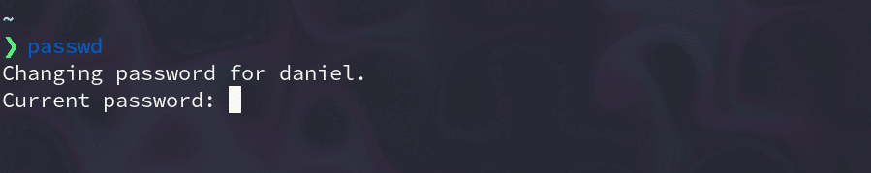](https://kinsta.com/wp-content/uploads/2021/08/passwd-command.png)The passwd command

Be careful while using it — you don’t want to mess up your user password!

**28. which Command**

The which command outputs the full path of shell commands. If it can’t recognize the given command, it’ll throw an error.

For example, we can use this to check the binary path for [Python](https://kinsta.com/blog/python-tutorials/) and the [Brave web browser](https://kinsta.com/blog/brave-browser-review/):

which python

# /usr/bin/python

which brave

# /usr/bin/brave

**29. shred Command**

If you ever wanted a file to be almost impossible to [recover](https://kinsta.com/help/disaster-recovery/), shred can help you with this task. This command overrides the contents of a file repeatedly, and as a result, the given file becomes extremely difficult to recover.

Here’s a file with little content in it:

[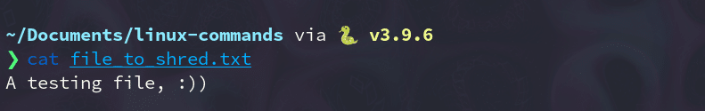](https://kinsta.com/wp-content/uploads/2021/08/file-to-shred.png)File to shred.

Now, let’s have shred do its thing by typing the following command:

shred file_to_shred.txt

[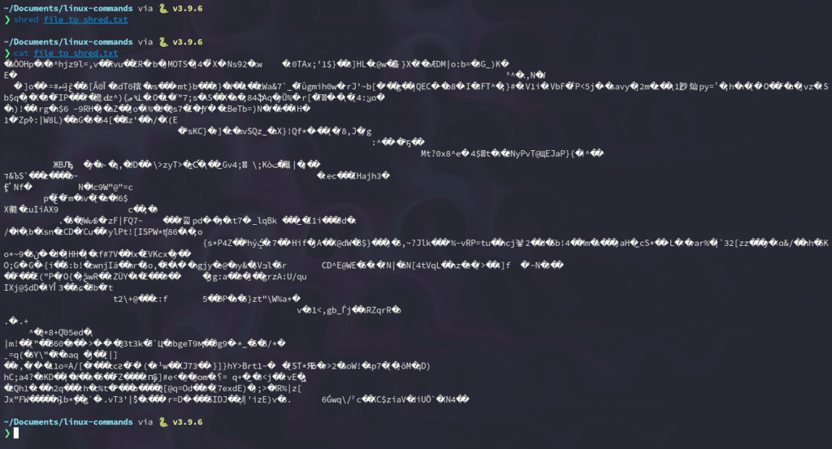](https://kinsta.com/wp-content/uploads/2021/08/Overwritten-content.png)Overwritten content.

If you want to delete the file right away, you can use the -u flag:

shred -u file_to_shred.txt

**30. less Command**

less (opposite of [more](https://man7.org/linux/man-pages/man1/more.1.html)) is a program that lets you inspect files backward and forward:

less large_text_file.txt

[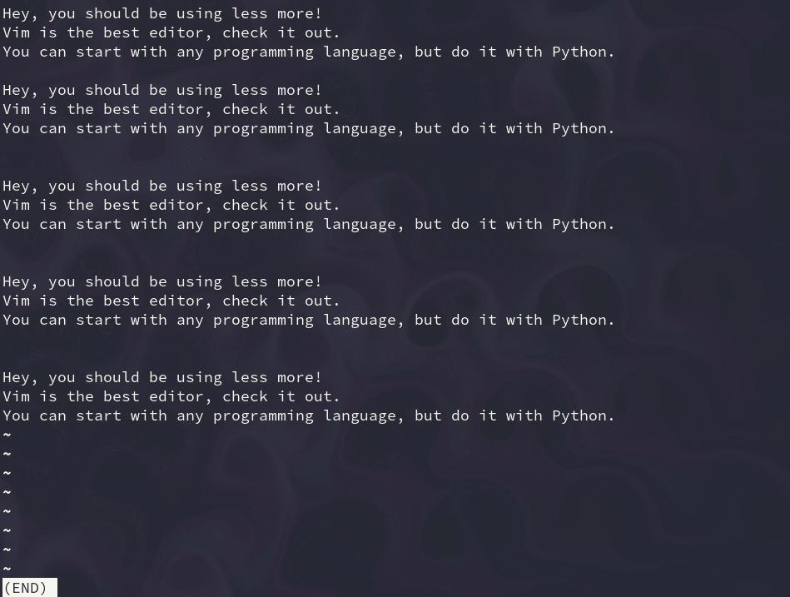](https://kinsta.com/wp-content/uploads/2021/08/less-command.png)The less command.

The neat thing about less is that it includes more and vim commands in its interface. If you need something more interactive than cat, less is a good option.

**31. tail Command**

Similar to cat, tail prints the contents of a file with one major caveat: It only outputs the last lines. By default, it prints the last 10 lines, but you can modify that number with -n.

For example, to print the last lines of a large text file, you’d use:

tail long.txt

[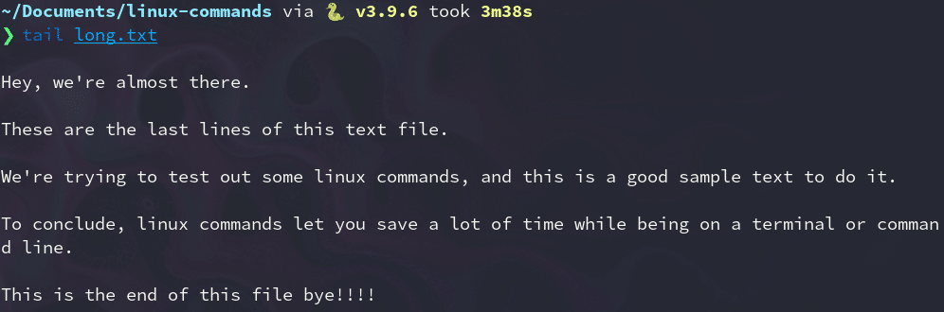](https://kinsta.com/wp-content/uploads/2021/08/tail-command.png)The tail command.

To view only the last four lines:

tail -n 4 long.txt

[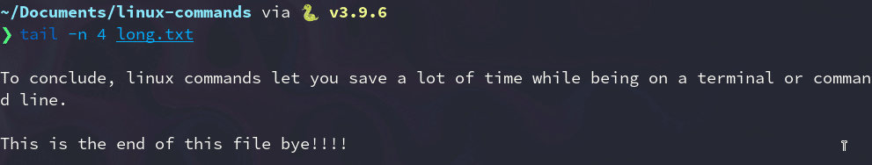](https://kinsta.com/wp-content/uploads/2021/08/tail-four-lines.png)tail four lines.

**32. head Command**

This one is complementary to the tail command. head outputs the first 10 lines of a text file, but you can set any number of lines you want to display with the -n flag:

head long.txt

head -n 5 long.txt

[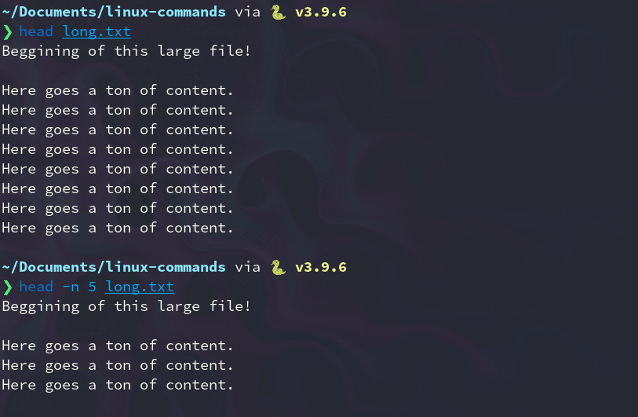](https://kinsta.com/wp-content/uploads/2021/08/head-command.png)The head command.

**33. grep Command**

Grep is one of the most powerful utilities for working with text files. It searches for lines that match a [regular expression](https://regex101.com/) and print them:

grep "linux" long.txt

[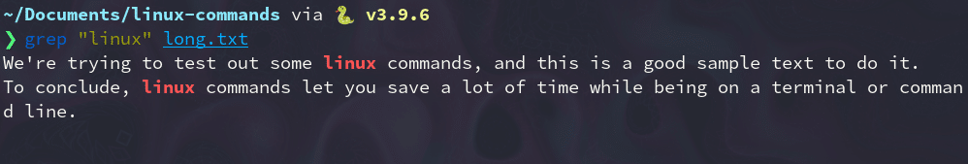](https://kinsta.com/wp-content/uploads/2021/08/grep-command.png)The grep command.

You can count the number of times the pattern repeats by using the -c flag:

grep -c "linux" long.txt

# 2

**34. whoami Command**

The whoami command (short for “who am i”) displays the [username](https://kinsta.com/knowledgebase/change-wordpress-username/) currently in use:

whoami

# kinsta

You would get the same result by using echo and the environmental variable $USER:

echo $USER

# kinsta

**35. whatis Command**

whatis prints a single-line description of any other command, making it a helpful reference:

whatis python

# python (1) - an interpreted, interactive, object-oriented programming language

whatis whatis

# whatis (1) - display one-line manual page descriptions

**36. wc Command**

Wc stands for “word count,” and as the name suggests, it returns the number of words in a text file:

wc long.txt

# 37 207 1000 long.txt

Let’s breakdown the output of this command:

* 37 lines
* 207 words
* 1000 byte-size
* The name of the file (long.txt)

If you only need the number of words, use the -w flag:

wc -w long.txt

207 long.txt

**37. uname Command**

uname(short for “Unix name”) prints the operative system information, which comes in handy when you know your current Linux version.

Most of the time, you’ll be using the -a (–all) flag, since the default output isn’t that useful:

uname

# Linux

uname -a

# Linux kinstamanjaro 5.4.138-1-MANJARO #1 SMP PREEMPT Thu Aug 5 12:15:21 UTC 2021 x86_64 GNU/Linux

**38. neofetch Command**

[Neofetch](https://github.com/dylanaraps/neofetch) is a CLI (command-line interface) tool that displays information about your system — like kernel version, shell, and hardware — next to an ASCII logo of your Linux distro:

neofetch

[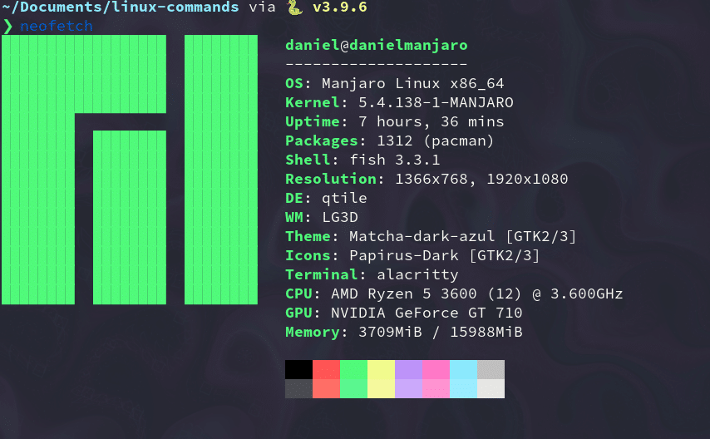](https://kinsta.com/wp-content/uploads/2021/08/neofetch.png)The neofetch command.

In most machines, this command isn’t available by default, so make sure to install it with your package manager first.

**39. find Command**

The find command searches for [files in a directory](https://kinsta.com/knowledgebase/wordpress-files/) hierarchy based on a regex expression. To use it, follow the syntax below:

find [flags] [path] -name [expression]

To search for a file named **long.txt** in the current directory, enter this:

find ./ -name "long.txt" # ./long.txt

To search for files that end with a **.py** (Python) extension, you can use the following command:

find ./ -type f -name "*.py" ./get_keys.py ./github_automation.py ./binarysearch.py

**40. wget Command**

wget (World Wide Web get) is a utility to retrieve content from the internet. It has one of the largest collections of flags out there.

Here’s how you would download a Python file from a [GitHub](https://kinsta.com/knowledgebase/what-is-github/) repo:

wget https://raw.githubusercontent.com/DaniDiazTech/Object-Oriented-Programming